
M.V.P SAMAJ’S

K.T.H.M. COLLEGE, NASHIK
(K.R.T. Arts, B.H. Commerce , A.M. Science College, Nashik) A PROJECT REPORT ON

“Performance Analysis of Mutual Funds Using ANOVA and Risk-Return Measures”
SUBMITTED BY
Ekta Kapadnis , Omkar Dhepale , Chetana Sonavane, Devendra Ahire, Vaibhav Aher

SUBMITTED TO



Savitribai Phule Pune University

M.V.P. Samaj’s K.R.T. Arts, B.H. Commerce C A.M. Science College, Nashik
Department of Statistics

(Asa part of curriculum for partial fulfillment of bachelor's degree)

Under the Guidance of

Dr. Kalpesh Amrutkar


M .V.P SAMAJ’S

K.T.H.M. COLLEGE, NASHIK
(K.R.T. Arts, B.H. Commerce , A.M. Science College, Nashik)
Affiliated to Savitribai Phule Pune University
CERTIFICATE

This is to certify that the project report entitled “Performance Analysis of Mutual Funds Using ANOVA and Risk-Return Measures”
is a Bonafide work carried out by:

Ekta Kapadnis , Omkar Dhepale , Chetana Sonavane, Devendra Ahire, Vaibhav Aher
The student of T.Y.B.Sc Statistics, K.T.H.M College, Nashik, with partial fulfillment of the statistics project of the Pune University during the year 2024–2025. The project report has been approved as it satisfies the academic requirements in respect of project work prescribed for the said degree

Dr. Kalpesh Amrutkar |  | Dr. Nutan Khangar
(Project Guide) | External Examiner | (Head of Department)
Department of Statistics  K.T.H.MCollege, Nashik |  | Department of Statistic  K.T.H.M College, Nashik


M .V.P SAMAJ’S

K.T.H.M. COLLEGE, NASHIK
(K.R.T. Arts, B.H. Commerce , A.M. Science College, Nashik)
Affiliated to Savitribai Phule Pune University

DECLARATION BY STUDENTS
We, T.Y.B.Sc (Statistics) students hereby declare that the project entitled “Performance Analysis of Mutual Funds Using ANOVA and Risk-Return Measures” is our original work and has not been submitted for any degree, diploma or other similar titles elsewhere.
This has been undertaken for the purpose of under Graduate in Statistics during the academic year 2025–2026 at K.R.T Arts, B.H. Commerce C A.M. Science College, Nashik

Place: Nashik
Date: / / 2025

Ekta Kapadnis Omkar Dhepale Chetana Sonavane Devendra Ahire Vaibhav Aher

ACKNOWLEDGEMENT
It is a great pleasure to submit this project report entitled

“Performance Analysis of Mutual Funds Using ANOVA and Risk-Return Measures”
This study is carried out as a part of the curriculum for the partial fulfillment of the bachelor's degree of Savitribai Phule Pune University.
Words on a paper are mere ink marks, but when they carry a purpose, they reflect meaningful efforts. We take this opportunity to express our sincere gratitude towards all those individuals whose guidance and support made this project successful.
We are also thankful to the Principal of K.T.H.M. College, Dr. K. M. Ahire, for support and encouragement.
We are highly indebted to Dr. Nutan Khangar, Head of the Department of Statistics, for his valuable guidance, constant supervision, and encouragement throughout this project.
Our sincere thanks to Dr. Kalpesh Amrutkar & Dr. Nutan Khangar for their continuous support, insightful suggestions, and motivation in completing this project successfully.
We also extend our gratitude to all the staff members of the Department of Statistics for their cooperation and support during the course of this
project.
Finally, we would like to thank our friends, classmates, and family members for their encouragement and support, without which this project would not have been possible.



Sr. No | Content | PAGE NO.
1 | INTRODUCTION
2 | MOTIVATION
3 | OBJECTIVE
4 | ABSTRACT
5 | LITERATURE
6 | RESEARCH METHODOLOGY
7 | DATA ANALYSIS
8 | CONCLISION
9 | LIMITATION
10 | FUTURE SCOPE
11 | REFERENCE

INTRODUCTION

Mutual funds can be characterized as a popular form of investment vehicle that provides diversification, professional management, and broad accessibility to a wide range of investors. Mutual funds collect funds from a large number of investors and invest them in assets such as shares, bonds, and money market securities.
Although mutual funds provide opportunities for wealth creation, they face a variety of risks, such as market risk, credit risk, interest rate risk, and liquidity risk. Therefore, a deep understanding and analysis of mutual fund risks are critical for making sound investment decisions.
One of the key aspects of mutual fund analysis is to understand how their performance changes over time and how various factors affect their performance. For instance, regression analysis is widely used to measure the correlation between mutual fund returns and market-related factors such as stock market indices, interest rates, and macroeconomic
indicators. This analysis can help to identify fund return sensitivity to market movements and compute risk measures such as beta.
The present study is based on the application of regression and reliability techniques in the evaluation of the mutual fund's risk. The research is based on the historical data of the mutual funds, which are scrutinized in the present study. Regression and reliability techniques are applied in the present study to understand the pattern of the mutual funds and the risks associated.
The present study is very effective in providing the investors, analysts, and portfolio managers better knowledge and understanding of the mutual
funds and the associated risks. By the application of regression and reliability techniques, the present study is expected to provide a better understanding of the mutual funds and the associated risks.

MOTIVATION

Mutual funds are one of the most common forms of investment, and they are known for providing diversification and professional management.
However, the performance of mutual funds is not stable and is affected by factors like market fluctuations, interest rates, and economic conditions. Therefore, there is always a need to understand and analyze the risks associated with mutual funds.
In many cases, the performance of mutual funds is seen to fluctuate in
terms of sudden increases or decreases. This is due to the dynamic nature of financial markets. To analyze the performance of mutual funds, one can make effective use of the regression method, which helps to understand
the relationship between the performance of mutual funds and the financial market.
It is also important to analyze the reliability of mutual fund performance. This is because, in the financial world, one can rarely be sure of the performance of mutual funds, and there is always a possibility of sudden losses.
The motivation for conducting this study is to make effective use of the combination of regression and reliability methods to analyze the risks associated with mutual funds. This helps to gain a better understanding of mutual fund performance and make effective decisions.

OBJECTIVE
- To analyze the performance of selected small-cap mutual funds from SBI, UTI, Nippon, Mirae Asset, and HDFC.

- To compare the returns (NAV returns) of the selected mutual funds over a specified time period.

- To examine the consistency and variability in returns among the selected mutual funds.

- To evaluate which mutual fund performs better based on statistical analysis.

- To understand the effectiveness of investment strategies adopted by different Asset Management Companies.

- To provide insights for investors in selecting suitable Large-cap mutual funds based on performance comparison.

ABSTRACT

The present study aims to investigate the risks and performance associated with mutual funds by using regression and reliability techniques. The data set is based on the historical data of the Net Asset Value (NAV) of specific mutual funds over a specified period. Initially, the data is converted into
returns to improve the data's statistical properties. Descriptive statistics and data visualization are employed to understand the behavior of the data.
The regression technique is employed to examine the relationship between the returns of the mutual funds and the relevant market factors, such as
the benchmark indices. This helps in the estimation of the important risk parameters and the understanding of the sensitivity of the mutual funds to market movements.
A part from regression, the reliability technique is employed to examine the stability of the mutual funds in the market. This technique provides the
estimates of the possibility of achieving the expected returns and the associated risks of extreme changes in the market.
The results of the study reveal that the regression technique is effective in understanding the relationship between the returns of the mutual funds and the market factors. At the same time, the reliability technique provides valuable results in understanding the stability of the mutual funds in the market.

  - Introduction

Literature

The mutual fund industry in India started in 1963 with the formation of Unit Trust of India, at the initiative of the Government of India and Reserve Bank of India. The history of mutual funds in India can be broadly divided into four distinct phases

First Phase - 1G64-1G87
Unit Trust of India (UTI) was established in 1963 by an Act of Parliament. It was set up by the Reserve Bank of India and functioned under the Regulatory and administrative control of the Reserve Bank of India. In 1978 UTI was de-linked from the RBI and the Industrial Development Bank of India (IDBI) took over the regulatory and administrative control in place of RBI. The first scheme launched by UTI was Unit Scheme 1964. At the end of 1988 UTI had Rs. 6,700 crore of assets under management.

Second Phase - 1G87-1GG3 (Entry of Public Sector Funds)
1987 marked the entry of non-UTI, public sector mutual funds set up by public sector banks and Life Insurance Corporation of India (LIC) and General Insurance Corporation of India (GIC). SBI Mutual Fund was the first non-UTI Mutual Fund established in June 1987 followed by Can bank Mutual Fund (Dec 87), Punjab National Bank Mutual Fund (Aug 89), Indian Bank Mutual Fund
(Nov 89), Bank of India (Jun 90), Bank of Baroda Mutual Fund (Oct 92). LIC established its mutual fund in June 1989 while GIC had set up its mutual fund in December 1990. At the end of 1993, the mutual fund industry had assets under management of Rs. 47,004 crore.

Third Phase - 1GG3-2003 (Entry of Private Sector Funds)
With the entry of private sector funds in 1993, a new era started in the Indian mutual fund industry, giving the Indian investors a wider choice of fund families. Also, 1993 was the year in which the first Mutual Fund Regulations came into being, under which all mutual funds, except UTI were to be registered and governed. Theirs while Kothari Pioneer (now merged with Franklin Templeton) was the first private sector mutual fund registered in July 1993. The 1993 SEBI (Mutual Fund) Regulations were substituted by a more comprehensive and revised Mutual Fund Regulations in 1996. The industry now functions under the SEBI (Mutual Fund) Regulations 1996. The number of mutual fund houses went on increasing, with many foreign mutual funds setting up funds in India and also the industry has witnessed several mergers and acquisitions. At the end of January 2003, there were 33 mutual funds with total assets of Rs. 1, 21,805 crore. The Unit Trust of India with Rs. 44,541 crore of assets under management was way ahead of other mutual funds.

Fourth Phase - Since February 2003

In February 2003, following there peal of the Unit Trust of India Act 1963 UTI was bifurcated into two separate entities. One is the Specified Undertaking of the Unit Trust of India with assets under 3 management of Rs. 29,835 crore as at the end of January 2003, representing broadly, the assets of US 64 scheme, assured return and certain other schemes. The Specified Undertaking of Unit Trust of India, functioning under an administrator and under the rules framed by Government of India and does not come under the purview of the Mutual Fund Regulations. The second is the UTI Mutual Fund, sponsored by SBI, PNB, BOB and LIC. It is registered with SEBI and functions under the Mutual Fund Regulations.
With the bifurcation of the erstwhile UTI which had in March 2000 more than Rs. 76,000 crore of assets under management and with the setting up of a UTI Mutual Fund, conforming to the SEBI Mutual Fund Regulations, and with recent mergers taking place among different private sector funds, the mutual fund industry has entered its current phase of consolidation and growth.

  - Parties Involved In Mutual Funds

SEBI | It is the governing authority of stock market. Mutual funds legal framework is regulated by SEBIs guidelines
Investors | Investor is another speculator (who takes on high risks for high rewards) but one whose primary objective are to safeguard the principle investment,  a steady income and capital appreciation
Trustees | The mutual fund has been formed as a public trust and trustees manage the trust. They are primarily accountable for protecting the interest  of mutual fund investors.
Asset Management Company | SEBI approved asset management company manage the fund by making investment in various types of securities. It manages the investment portfolios o the schemes and handles various other routine activities incidental to the mutual fund business.  Its income comes from the  management fees it charges for schemes it manages
Distributors | They earn commission  for bringing in investors into the schemes of  mutual fund. This commission is an expense for the schemes.
Registers | An investor holding in mutual fund schemes is typically followed by the schemes RTA (Registrar and transfer Agent).  Some AMC‟s prefer to handle it in house.

Custodian/ Depository | As the name suggests, a custodian of the securities preserves the custody  of the securities in which the scheme invests. Therefore, for an investment transaction of mutual fund, custodian receives or gives delivery.

Mutual Funds


A mutual fund is a type of professionally managed investment fund that pools money from many investors to purchase securities such as stocks, bonds, money market instruments and other assets. Mutual funds are operated by professional money managers, who allocate the fund's investments and attempt to produce Capital gains and/or income for the fund's investors.
Some Key Features of a Mutual Fund are as Follows
    - Professional Management
Each fund's investments are chosen and monitored by qualified professionals who use this money to create a portfolio. That portfolio could consist of stocks, bonds, money market instruments or a combination of all of these.
    - Fund Ownership
An investor owns shares of mutual fund, not the individual secures. Mutual funds permit the investors to invest small amounts of money. The pool can be
used to buy even those securities. which would have been out of reach of a common

individual investor. Thus investors in mutual funds benefit from being involved in a large pool of cash invested by other people.

    - Diversified Investment
Mutual funds have a diversified investment portfolio which helps in minimizing the risk as the fluctuation in prices of the individual securities has less effect on the fund's
performance.

  - Benefits Of Mutual Funds

    - Risk Diversification

Mutual funds help to diversify the risk associated with the securities, because Overall risk of the particular mutual fund is proportionately divided among all the unit holders of mutual fund.
    - Operated by Professional Manager

Mutual funds are kept and operated by the professional managers who are professional in this particular field so the unit holders enjoy the professional operation on these mutual funds.
    - Passive Investment Style

Mutual fund is a passive investment style in which the owners of the unit holders do not participate directly but they keep these units passively. They don't need to participate directly they only have to purchase the units and keep them passive way

Classification of Mutual Funds
Based on Maturity Period

    - Open-Ended Funds:

An open ended fund is a fund that is available for subscription and can be redeemed on a continuous basis. It is available for subscription throughout the year and investors can buy and sell units at NET ASSET VALUE (NAV) related prices. These funds do not have a fixed maturity date. The key feature of an open-ended fund is liquidity.
    - Close-Ended Funds:

A close ended fund is a fund that has a defined maturity period, for example 5-7 Years. These funds are open for subscription for a specified period at the time of initial launch. These funds are listed with a recognized stock exchange.
    - Exchange Traded Funds:

Exchange traded funds combine the features of open-ended and close-ended funds. These funds may trade on stock exchanges and are open for sale or redemption at predetermined intervals on the prevailing NET ASSET VALUE (NAV).
    - Unit Investment Trusts

UTIs are also issued to the public only once when they are created. They have a fixed maturity period and a fixed portfolio of securities which is determined at the time of creation.

Based on Investment Objectives or Asset Class
- Equity/Growth Funds:

Equity funds invest minimum 65% of its corpus in equity and equity related securities. These funds may invest in a wide range of industries or focus on one or more industry sectors. These types of funds are suitable for investors with a long-term outlook and higher risk appetite. Types of Equity Funds:
- Large Cap Fund:

An open ended equity schemes predominantly investing in large cap stocks. The
minimum investment in equity and equity related instruments of large cap companies shall be 80 % of total asset.
- Mid Cap Fund:

An open ended equity schemes predominantly investing in mid cap stocks. The
minimum investment in equity and equity related instruments of large cap companies shall be 65 % of total asset.
- Small cap Fund:

An open ended equity schemes predominantly investing in small cap stocks. The
minimum investment in equity and equity related instruments of large cap companies shall be 65 % of total asset.
- Multi Cap Fund:

An open ended equity scheme investing in across large cap, mid cap, small cap stocks. The minimum investment in equity and equity related instruments of large cap companies shall be 65
% of total asset.

- ELSS (Equity linked saving schemes):

An open ended equity linked saving schemes with a statutory lock in of 3 years and tax benefit. The minimum investment in equity and equity related instruments shall be 80 % of total asset.

- Debt/Income Funds:

Debt/income funds generally invest in securities such as bonds, corporate debentures, government securities and money market instruments. These funds invest minimum 65% of their corpus in fixed income securities. By investing in debt instruments, these funds provide low risk and stable income to investors with preservation of capital. These funds tend to be less volatile than equity funds and produce regular income.

Types of Debt fund:

- Liquid Fund:

An open ended liquid scheme whose investment is into debt and money market securities with maturity of up to 91 days only.
- Ultra Short Duration Fund:

An open ended Ultra-Short term debt schemes investing in debt and money market instruments with Macaulay duration between 3 months and 6 months.
- Low duration fund:

An open ended low duration debt scheme investing in debt and money market instruments Macaulay duration between 6 months and 12 months.
- Short duration Fund:

An open ended short term debt scheme investing in debt and money market instruments having maturity up to 1 year.
- Medium to Large Duration Fund:

An open ended medium term debt scheme investing in debt and money market instruments with Macaulay duration between 4 years and 7 years. Portfolio Macaulay duration greater than 7 years.
- Money Market Fund:

An open ended debt scheme investing in money market instruments having maturity up to 1 year.

- Corporate Bond Fund:

An open ended debt scheme predominantly investing in AA+ and above rated corporate bonds. The minimum investment in corporate bonds shall be 80 percent of total assets.

- Balanced/Hybrid Funds:

Balanced Funds invest in both equities and fixed income instruments in line with the pre- determined investment objective of the scheme. These funds provide both stability of returns and capital appreciation to investors

Types of Hybrid Funds
- Aggressive Hybrid Fund:
An open ended hybrid scheme investing predominantly in equity and equity related instruments.
Invest in equity and equity related instruments shall be between 65
percent and 80 percent of total asset while investment in debt instrument shall be between 20 percent and 35 percent of total asset.

Balanced Hybrid Fund:
An open ended scheme investing in equity and debt instruments. The investment in
equity and equity related instruments shall be 40 percent and 60 percent of total assets while investment in debt instrument shall be between 40 percent and 60 percent. No arbitrage is permitted in these schemes

Conservative Hybrid Fund:

An open ended hybrid scheme investing predominantly in debt instruments shall be between 75 percent and 90 percent total asset while in equity and equity related instruments shall be 10 percent and 25 percent of total asset.

Other Schemes

- Tax Saving Funds:
Tax-saving schemes offer tax rebates to investors under specific provisions of the Income tax Act1961. These are growth-oriented schemes and invest primarily in
equities. Like an equity scheme, they largely suit investors having a higher risk appetite and aim to generate appreciation over medium to long run.
- Index Funds:
Index Funds replicate the performance of a particular index such as the BSE Sensex or the SCP CNX Nifty. The portfolio of these schemes consist of only those stocks that represent the index and the weightage assigned to each stock is aligned to the stock’s weightage in the index.
- Sector-Specific Funds:
Sector-specific Funds invest in the securities of only those sectors or industries as specified in the scheme information department. The returns in these funds are
dependent on the performance of the respective sector/industries.

2.4.mportant Key Words Related To Mutual Funds
NAV: Net asset value refers to the total value of the related mutual fund scheme. It shows the overall value which may vary everyday as per the changes in the market.
Units: The value of mutual fund is divided into units as per the number of persons it is sold. The value of each unit changes every day.
Unit holder: The investor who purchases the units of mutual funds is called unit holder. He/she may keep as many units as he/she wants.

Systematic Investment Plan (SIP)

A Systematic Investment Plan (SIP) is a method of investing in mutual funds where a fixed amount is invested at regular intervals (monthly, quarterly, etc.) instead of investing a lump sum. SIP is widely used by investors to build wealth in a disciplined and gradual manner.
SIP works on the principle of rupee cost averaging, where investors buy more units when prices are low and fewer units when prices are high. This helps in reducing the overall cost of investment and minimizes the impact of market volatility. Additionally, SIP benefits from the power of compounding, where returns generated over time are reinvested, leading to higher long- term growth.
In the context of this study, SIP can be considered as an effective investment approach for small-cap mutual funds, which are generally more volatile in nature. By investing regularly through SIP, investors can manage risk and benefit from long-term market growth. It also allows investors with limited capital to participate in mutual fund investments without requiring a large initial amount.

List of selected of Mutual Fund

HDFC Asset Management Company


on research and market analysis.
HDFC Mutual Fund manages investor moneyby investing in diversified portfolios of equity, debt, and hybrid securities based

Type | Public
Industry | Mutual Funds
Founded | 1999
Headquarters | Mumbai, India
Area served | India
Key people | Mr. Navneet Munot (Managing Director CEO) Mr. Prashant Jain (Former CIO)  Senior investment team members
Products | Mutual Funds, Portfolio Management Services, Investment Advisory
AUM | Approx. ₹5,00,000+ crore (varies with market, recent estimates)
Number of employees | 1000–1500 (approx.)


Mirae Asset Mutual Fund

Mirae Asset Mutual Fund manages investments across equity, debt, andhybrid
funds using research-driven strategies and global investment expertise.
It offers investor services such as SIPs, online transactions, and regular portfolio updates with transparent NAV disclosures.

Type | Public
Industry | Mutual Funds
Founded | 2007 (India operations)
Headquarters | Mumbai, India
Area served | India
Key people | Mr. Swarup Mohanty (CEO) Senior investment team members
Products | Mutual Funds, Portfolio Management Services,  Investment Advisory
AUM | Approx. ₹1,50,000+ crore (varies with market)
Number of employees | 800–1200 (approx.)

SBI Mutual Fund



SBI Mutual Fund is one of India’s largest asset
management companies, offering a wide range of equity, debt, and hybrid schemes. It focuses on long-term wealth creation through diversified investments and strong research-based strategies.
The fund operates under strict regulations of Securities and Exchange Board of India

Type | Public
Industry | Mutual Funds
Founded | 1963
Headquarters | Mumbai, India
Area served | India
Key people | Mr. Imtaiyazur Rahman (MD C CEO)
Products | Mutual Funds, Retirement Solutions, Portfolio Management
AUM | Approx. ₹2,50,000+ crore
Number of employees | 800-1000(Approx)

UTIMUTUAL FUND


investment management.
\

UTI Mutual Fund is one of the oldest mutual fund
institutions in India with a strong legacy in

It offers a variety of schemes focused on wealth creation, income generation, and retirement planning.
The funds sures transparency and compliance under Securities and Exchange Board of India regulations.

Type | Public
Industry | Mutual Funds
Founded | 1963
Headquarters | Mumbai, India
Area served | India
Key people | Mr. Imtaiyazur Rahman (MD C CEO)
Products | Mutual Funds, Retirement Solutions, Portfolio Management
AUM | Approx. ₹2,50,000+ crore
Number of employees | 800–1000 (approx.)

NIPPON MUTUAL FUND


Nippon India Mutual Fund provides diverse investment solutions including mutual funds, ETFs, and portfolio management services.
It emphasizes innovation, wide investor reach, and consistent performance across different market conditions. The company follows regulatory guidelines set by Securities and Exchange Board of India.

Type | Public
Industry | Mutual Funds
Founded | 1995
Headquarters | Mumbai, India
Area served | India
Key people | Mr. Sundeep Sikka (ED C CEO)
Products | Mutual Funds, ETFs, Portfolio Management
AUM | Approx. ₹4,00,000+ crore
Number of employees | 900–1200 (approx.)

Research Methodology

DESCRIPTIVE
The performance of selected mutual funds managed by Indian Asset Management Companies (AMCs) is examined and compared in this study using a descriptive research approach. The research focuses on analyzing return patterns and performance differences among funds.

The sampling framework includes selected mutual funds from major AMCs such as SBI, UTI, Nippon, Mirae Asset, and HDFC. The selection is based on factors like fund popularity, historical performance, and market presence.
Data is collected from reliable financial sources and analyzed using Python and Excel. Statistical techniques, including Analysis of Variance (ANOVA), are applied to compare the returns and identify whether significant differences exist among the selected
mutual funds.

SOURCES OF DATA

- The study is based on secondary data collected from the Association of Mutual Funds in India (AMFI) official website and other financial platforms.
- The analysis considers five mutual funds, namely SBI, UTI, Nippon, Mirae Asset, and HDFC, based on data collected over the last five years

VARIABLES

Independent Variable: MUTUAL FUNDS
The different mutual funds (SBI, UTI, Nippon, Mirae Asset, HDFC) are treated as
independent variables. These represent different investment strategies and portfolio management styles across AMCs.
Dependent Variable: RETURNS / NAV RETURNS
The returns (or NAV returns) of the selected mutual funds are considered as the
dependent variable. These returns are used to evaluate and compare the performance of each fund.

TOOLS AND TECHNIQUES

The study uses Python and Microsoft Excel for data analysis. Statistical techniques such as ANOVA (Analysis of Variance) are applied to determine whether there are significant differences in returns among the selected mutual funds.
Python libraries (such as pandas, numpy and stats models) are used for data processing and visualization, while Excel is used for data organization and preliminary analysis. The results help in understanding performance variation and investment
effectiveness across different AMCs.

DATA ANALYSIS

DESCRIPTIVE

HDFC Mutual Fund

Variance | 0.000928538
Mean | 0.01337359
Minimum | -0.05643273
Maximum | 0.082510194
standard deviation | 0.030471926
Table showing Descriptive Data of HDFC Mutual fund Returns.
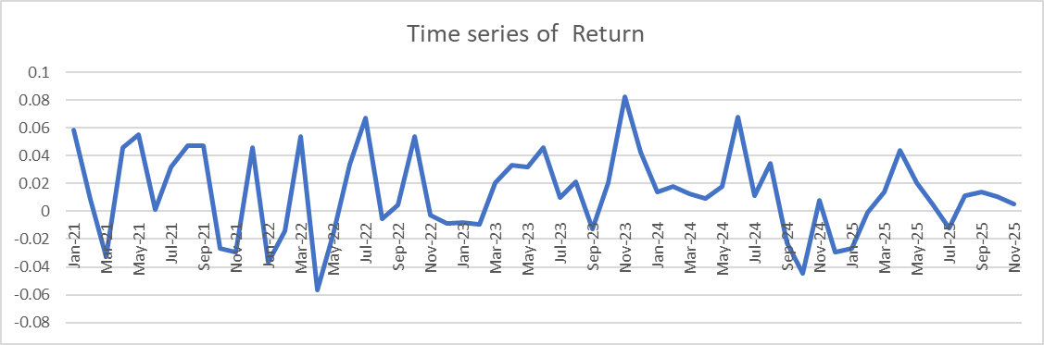
Graph showing time series of returns.

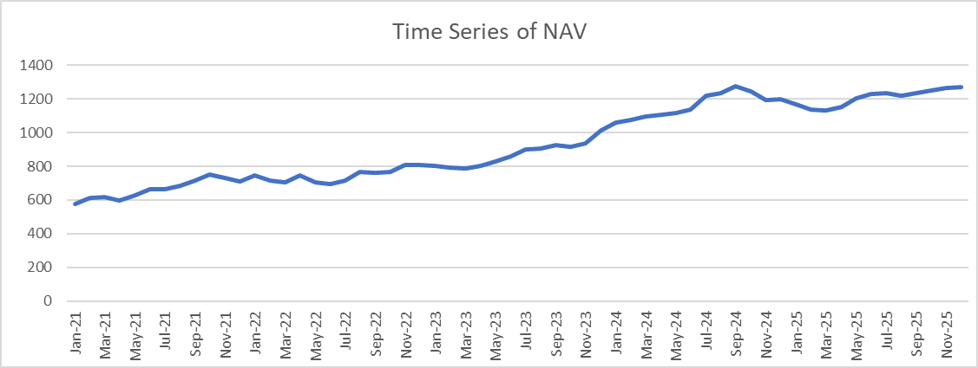
Graph showing the time series of NAV(Net Assets value).

  - Regression for Calculation of Alpha and Beta
Regression analysis is used to measure the relationship between mutual fund returns and market returns. It helps in estimating Alpha and Beta, which are important measures of fund performance and market risk.

  - Alpha(α) shows the extra return earned by the fund compared to the market.
  - Beta (β) shows how much the fund return changes when the market return changes.

Formula for Beta

β= 𝒄𝒐𝒗(Rp,Rm)
𝒗𝒂𝒓(Rm)
    - Rp= Fund return
    - Rm= Market return
    - Cov = Covariance
    - Var = Variance

Formula for Alpha
α= Rp- β Rm
    - Rp = Average fund return
    - Rm = Average market return
    - β = Beta value

Regression Table

Parameter | Value | Interpretation
Alpha (Intercept) | 0.007835 | The fund generated positive excess return.
Beta (Slope) | 0.502298 | The fund is less volatile than the market.
R-squared | 0.341982 | 34.20% of the variation in fund returns is explained by market returns
Method Used | Linear Regression | Relationship estimated between fund and market return

INTERPRETATION

    - The HDFC Mutual Fund shows a positive average return (1.34%) with moderate volatility, indicating stable performance and manageable investment risk.
    - The return series shows regular fluctuations with both positive and negative values, indicating normal market variability and moderate risk over the study period.
    - The NAV shows a steady upward trend from 2021 to 2025, indicating consistent growth and strong long-term performance of the HDFC Mutual Fund.
    - The regression was performed to estimate Alpha and Beta of the mutual fund. The positive Alpha indicates better performance compared to the market, while the Beta value less than 1 shows that the fund has lower risk than the market. Therefore, regression analysis helps evaluate the performance and risk level of the mutual fund.

Mirae Mutual Fund

Mean | 0.011353301
Variance | 0.000895523
Minimum | -0.062041048
Maximum | 0.074497988
Standard Deviation | 0.029925287

Table showing Descriptive Data of Mirae Mutual fund Returns.
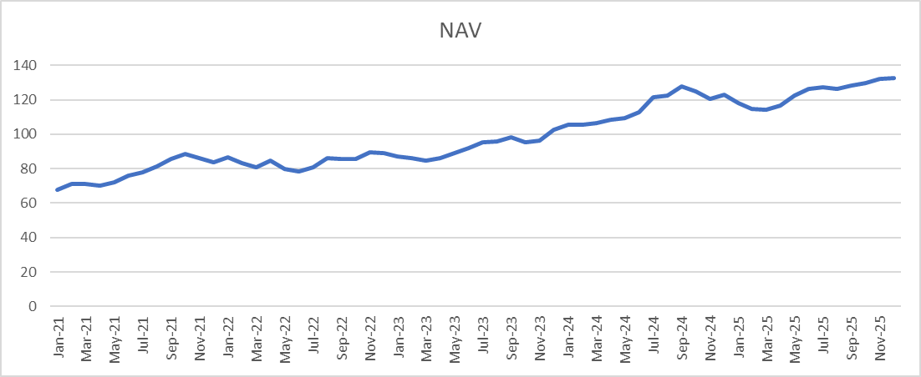

Graph showing the time series of NAV(Net Assets value).
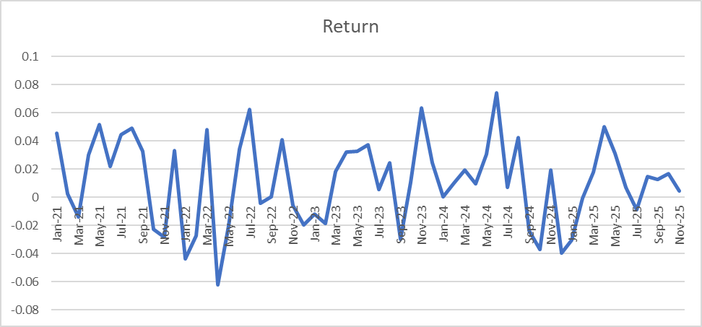
Graph showing time series of returns.

Regression Table

Parameter | Value | Interpretation
Alpha (Intercept) | 0.00582541 | The fund generated positive excess return.
Beta (Slope) | 0.50140816 | The fund is less volatile than the market.
R-squared | 0.35333411 | 35.33% of the variation in the fund’s return is explained by market return.

INTERPRETATION
The average return is 1.14% with a standard deviation of 0.0299, indicating moderate volatility.
The NAV shows a steady upward trend from 2021 to 2025, indicating consistent growth and positive long-term performance of the mutual fund.
The return series shows regular fluctuations with both positive and negative values, reflecting normal market variability and moderate investment risk.
The positive Alpha indicates better performance compared to the market, while the Beta value less than 1 shows that the fund has lower risk than the market. Therefore, regression helps evaluate the performance and risk level of the mutual fund.

NIPPON Mutual fund

Mean | 0.015763629
Variance | 0.000975311
Minimum | -0.058103213
maximum | 0.075588707
standard deviation | 0.031229977
Table showing Descriptive Data of Nippon Mutual fund Returns.

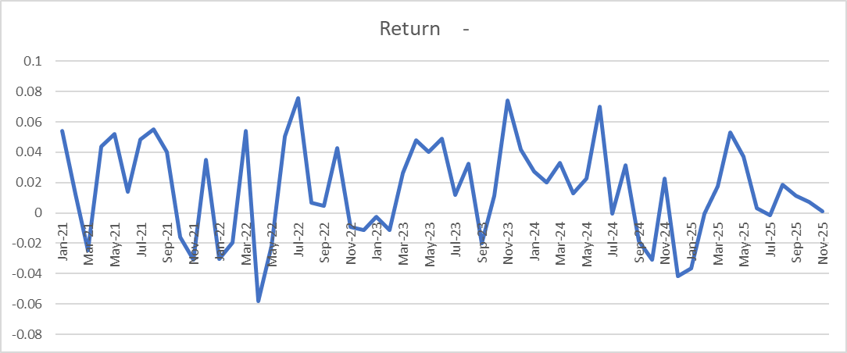
Graph showing time series of returns.

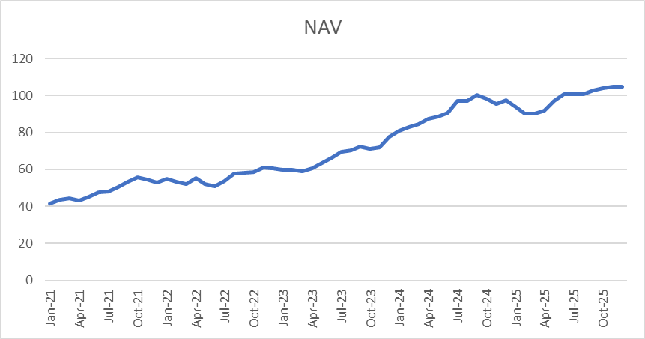
Graph showing the time series of NAV(Net Assets value).

Regression Table

Parameter | Value | Interpretation
Alpha (Intercept) | 0.010008 | The fund generated positive excess return.
Beta (Slope) | 0.52197 | The fund is less volatile than the market.
R-squared | 0.3515912 | 35.15% of the variation in the fund’s return is explained by market return.

INTERPRETATION
The average return is 1.58% with a standard deviation of 0.0312, indicating moderate volatility.
The return series shows frequent ups and downs with both positive and negative values, indicating normal market fluctuations and moderate risk over the study period.
The NAV shows a consistent upward trend from 2021 to 2025, indicating steady growth and improved performance of the mutual fund over time.

SBI Mutual fund

Mean | 0.01188398
Variance | 0.000847019
Minimum | -0.056367904
maximum | 0.064280226
standard deviation | 0.029103594
Table showing Descriptive Data of SBI Mutual fund Returns.

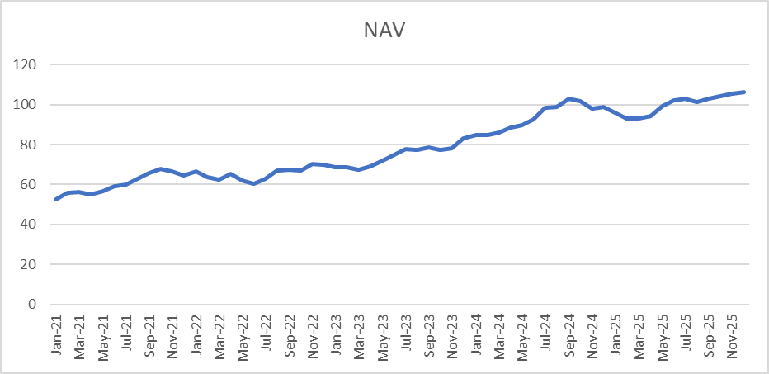
Graph showing the time series of NAV(Net Assets value).

Graph showing time series of returns.

Regression Table

Parameter | Value | Interpretation
Alpha (Intercept) | 0.00644 | The fund generated positive excess return.
Beta (Slope) | 0.49310 | The fund is less volatile than the market.
R-squared | 0.36129 | 36.12% Of the variation in the fund’s return is explained by market return.

INTERPRETATION
The average return is 1.19% with a standard deviation of 0.0291, indicating moderate volatility.
The NAV shows a steady upward trend from 2021 to 2025, indicating consistent growth and positive performance of the mutual fund over the study period.
The return series shows regular fluctuations with both gains and losses, reflecting normal market variability and moderate investment risk.

UTI Mutual fund

Mean | 0.010929584
Variance | 0.000892571
Minimum | -0.067942164
Maximum | 0.068472572
standard deviation | 0.02987592
Table showing Descriptive Data of UTI Mutual fund Returns.
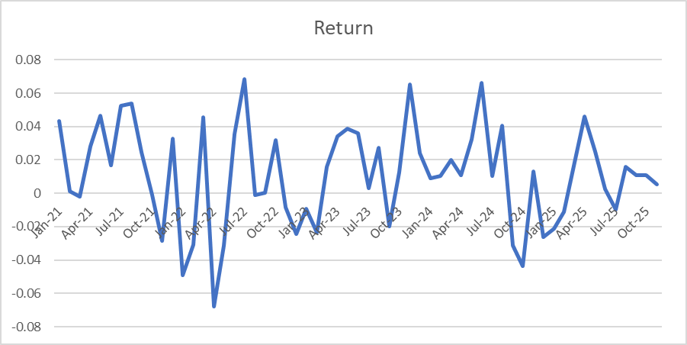
Graph showing time series of returns.
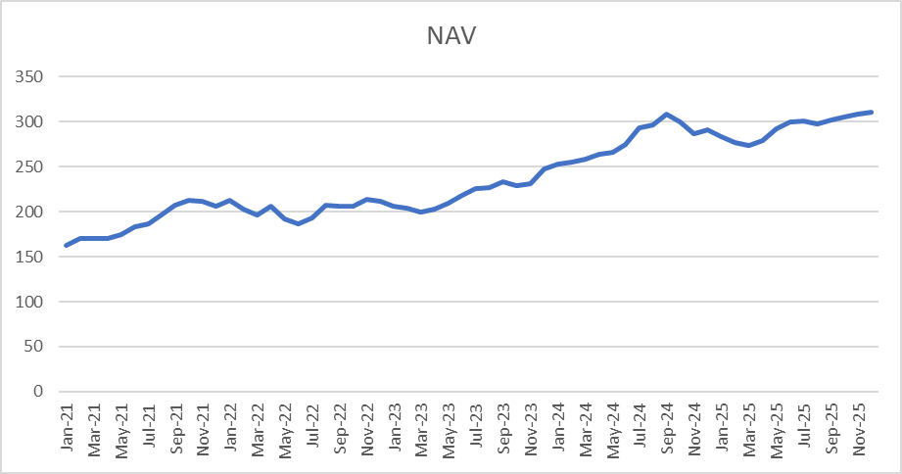

Graph showing the time series of NAV(Net Assets value).

Regression Table

Parameter | Value | Interpretation
Alpha (Intercept) | 0.00543 | The fund generated positive excess return.
Beta (Slope) | 0.49802 | The fund is less volatile than the market.
R-squared | 0.349741 | 34.97% of the variation in the fund’s return is explained by market return.

INTERPRETATION
The average return is 1.09% with a standard deviation of 0.0299, indicating moderate volatility.
The return series shows periodic fluctuations with both positive and negative values, indicating normal market variability and moderate investment risk.
The NAV shows a consistent upward trend from 2021 to 2025, indicating steady growth and improving performance of the mutual fund over the study period.

Alpha and Beta of Mutual Funds

 | HDFC | SBI | NIPPON | UTI | MIRAE
Alpha  (α) | 0.0078358 | 0.0064476 | 0.0100089 | 0.00554389 | 0.005825
Beta  (β) | 0.5022984 | 0.493105 | 0.5219765 | 0.49802926 | 0.50140

INTERPRETATION

The table presents the alpha (α) and beta (β) values of five selected mutual funds, which are key indicators used to evaluate fund performance and risk relative to the market.
      - Alpha (α) measures the excess return generated by a fund compared to the market benchmark.
        - Among the funds, Nippon Mutual Fund has the highest alpha (0.0100), indicating superior performance and better fund management.
        - HDFC and SBI also show positive alpha values, suggesting they have outperformed the benchmark to some extent.
        - UTI and Mirae Asset have comparatively lower alpha values, indicating relatively lower excess returns.
      - Beta (β) measures the sensitivity of a fund to market movements (market risk).
        - All funds have beta values close to 0.5, which means they are less volatile than the market and carry moderate risk.
        - Nippon has the highest beta (0.522), indicating it is slightly more responsive to market changes.
        - SBI has the lowest beta (0.493), suggesting relatively lower risk compared to others.

ANOVA TEST
- HDFC Mutual fund

Group 1: High values Group 2: Low values

Hypotheses
H₀ (Null Hypothesis): Mean High = Mean Low
H₁ (Alternative Hypothesis): Mean High ≠ Mean Low
Interpretation:
      - Large F → Means are different
      - Small F → Means are similar

PYTHON Code:
pip install stats models import pandas as pd
import stats models.api as sm
from stats models.formula.api import ols # data
High = [596.806,638.436,642.33,. , 1273.41,1282.041,1280.143]
Low = [557.536,585.417,592.348,. 1227.382,1245.802,1260.894]

# Create DataFrame data = pd.DataFrame({
'values': High + Low,
'group': ['High'] * len(High) + ['Low'] * len(Low)
})
# Fit ANOVA model
model = ols('values ~ C(group)', data=data).fit() # ANOVA table
anova_table = sm.stats.anova_lm(model, typ=2) print(anova_table)

OUTPUT :

Source of Variation | Sum Sq | df | F | p-value
  C(group) | 6.5544509 | 1.0 | 1.253748 | 0.265112
Residual | 6.16961 | 118.0 | NA | NA

CONCULSION: We Fail to reject H₀.
Since the p-value (0.2651) is greater than 0.05, there is no significant difference between the mean High and Low values. Therefore, both groups High and low values have similar average values.

MIRAE ASSET

Hypotheses
H₀ (Null Hypothesis): Mean High = Mean Low
H₁ (Alternative Hypothesis): Mean High ≠ Mean Low

SIMILAR PYTHON CODES USE IN ALL MUTUAL FUNDS

High = [69.998,73.483,73.353,71.435, , 130.265,132.573,133.619,133.778]
Low=[65.655,68.456,68.923,68.888, , 125.966,126.975,130.281,131.279]

OUTPUT :

Source of Variation | Sum Sq | df | F | p-value
C(group) | 722.045456 | 1.0 | 1.942259 | 0.166043
Residual | 43867.140142 | 118.0 | NA | NA

CONCULSION: We Fail to reject H₀.
Since the p-value (0.166043) is greater than 0.05, there is no significant difference between the mean High and Low values. Therefore, both groups High and low values have similar average values.

NIPPON FUND

Hypotheses
H₀ (Null Hypothesis): Mean High = Mean Low
H₁ (Alternative Hypothesis): Mean High ≠ Mean Low

High =[42.7469,45.4713,46.0063,44.237, ,104.5531,105.7985,105.6844,105.5389]

Low = [39.9285,41.8157,42.3903,41.9881, ,100.9907,102.0581,103.6683,104.014]

OUTPUT :

Source of Variation | Sum Sq | df | F | p-value
  C(group) | 414.326571 | 1.0 | 0.972373 | 0.326107
Residual | 50279.619727 | 118.0 | NA | NA
CONCULSION: We Fail to reject H₀.
Since the p-value (0.326107) is greater than 0.05, there is no significant difference between the mean High and Low values. Therefore, both groups High and low values have similar average values.

UTI Mutual Fund

Hypotheses
H₀ (Null Hypothesis): Mean High = Mean Low
H₁ (Alternative Hypothesis): Mean High ≠ Mean Low

High=[168.5553,176.1083,174.8186,172.99, , 307.1059,311.5361,312.536,313.2132]

Low=[157.2194,164.0418,165.6945, , 297.3295,299.4095,305.0751,307.6132]
OUTPUT :

Source of Variation | Sum Sq | df | F | P-value
  C(group) | 4078.201613 | 1.0 | 1.99597 | 0.16035
Residual | 241099.691156 | 118.0 | NA | NA

CONCULSION: We Fail to reject H₀.
Since the p-value (0.16035) is greater than 0.05, there is no significant difference between the mean High and Low values. Therefore, both groups High and low values have similar average values.

SBI Mutual Fund

· Hypotheses
H₀ (Null Hypothesis): Mean High = Mean Low
H₁ (Alternative Hypothesis): Mean High ≠ Mean Low

High = [54.5034,58.2201,58.1284,56.2546, , 104.5126,106.2858,106.7421,107.0651]

Low=[50.8227,53.4061,54.1407,53.804,. ,101.1985,101.8592,104.3705,105.2807]

OUTPUT :

Source of Variation | Sum Sq | df | F | p-value
  C(group) | 446.233303 | 1.0 | 1.633765 | 0.203692
Residual | 32229.559 | 118.0 | NA | NA

CONCULSION: We Fail to reject H₀.
Since the p-value (0.203692) is greater than 0.05, there is no significant difference between the mean High and Low values. Therefore, both groups High and low values have similar average values.

Conclusion

The analysis of selected mutual funds over the period 2021–2025 reveals a stable and consistent performance across all funds. The findings indicate that all funds generated positive mean returns ranging approximately from 1.09% to 1.58%, highlighting their profitability and potential for wealth creation. Among the selected funds, Nippon Mutual Fund delivered the highest average return, while UTI showed the lowest but maintained stable performance, reflecting reliability.

The study also shows that the standard deviation values for all funds fall within a moderate range, indicating controlled volatility and manageable risk levels. This suggests that the funds are suitable for investors with a balanced risk appetite. Additionally, the presence of negative skewness across all funds implies a slightly higher probability of downside movements; however, these are not extreme. The negative kurtosis further supports that the return distributions have fewer extreme fluctuations, resulting in smoother and more stable performance patterns.

The Net Asset Value (NAV) trends for all funds demonstrate a consistent upward movement over time, confirming strong long-term growth potential. From the Alpha–Beta analysis, it is observed that some funds generate positive alpha, indicating their ability to outperform the market benchmark and reflecting efficient fund management. Beta values are close to 1, suggesting that the funds are moderately sensitive to market movements—neither highly volatile nor overly defensive.

Overall, the combined findings conclude that the selected mutual funds are reliable investment options, offering moderate risk, steady returns, and consistent growth. These characteristics make them suitable for long-term investors seeking balanced and stable investment opportunities.

Limitations
- The study is limited to only five mutual funds, which may not represent the entire market.

- The time period (2021–2025) may not capture long-term economic cycles or extreme market conditions.

- Analysis is based mainly on historical data, which may not predict future performance accurately.

- External factors such as inflation, interest rates, and global events are not included in the model.

- The Alpha–Beta model assumes a linear relationship with the market, which may not always hold true.

- Data accuracy depends on the source, and any data inconsistency can affect results.

Future Scope

Inclusion of More Mutual Funds
The study can be expanded by including a larger number of mutual funds across different categories (equity, debt, hybrid) to provide a more comprehensive market analysis.

Longer Time Period Analysis
Extending the time frame beyond 2021–2025 would help capture different market cycles such as recession, boom, and recovery phases for better insights.

Comparison with Benchmark Indices
A deeper comparison with benchmark indices (like NIFTY 50 or Sensex) can enhance Alpha–Beta analysis and evaluate fund performance more precisely.

Inclusion of Macroeconomic Factors
Factors such as inflation, interest rates, GDP growth, and global economic events can be incorporated to understand their impact on mutual fund performance.

Sector-wise and Portfolio Analysis
Future research can analyze sector allocation and portfolio composition of mutual funds to identify performance drivers.

Investor Behavior Analysis
The project can be extended to study investor preferences, risk tolerance, and decision-making patterns in mutual fund investments.

Real-Time Data Analysis
Using live data through APIs and automation tools can help in continuous monitoring and dynamic analysis of mutual fund performance.

Comparison with Other Investment Options
The study can be broadened to compare mutual funds with other instruments like stocks, gold, ETFs, and fixed deposits for better investment decisions.

References for the Project
- Association of Mutual Funds in India – Official website for mutual fund data, NAV, and industry reports.
Website: https://www.amfiindia.com
- Securities and Exchange Board of India – Guidelines, regulations, and investor awareness resources.
Website: https://www.sebi.gov.in
- National Stock Exchange of India – Market index data used for Beta calculation.
Website: https://www.nseindia.com
- Bombay Stock Exchange – Historical market data and benchmark indices.
Website: https://www.bseindia.com
- Morningstar Investment Research – Mutual fund performance and risk analysis.
Website: https://www.morningstar.in
- Microsoft Excel – Used for data analysis, descriptive statistics, and graphs.
- Python (Jupyter Notebook) – Used for statistical analysis, return calculation, and Alpha–Beta computation.
- Kothari, C.R. – Research Methodology: Methods and Techniques (for research design and methodology).
- Gujarati, D.N. – Basic Econometrics (for regression, Alpha, and Beta concepts).
- Study material and lecture notes from Savitribai Phule Pune University (Statistics/Finance subjects).
- HDFC Mutual Fund – https://www.hdfcfund.com

- SBI Mutual Fund – https://www.sbimf.com

- UTI Mutual Fund – https://www.utimf.com

- Nippon India Mutual Fund – https://mf.nipponindiaim.com

- Mirae Asset Mutual Fund – https://www.miraeassetmf.co.in

DATA FILES
High and Low data set of selected Mutual Fund Funds NAV and Return of Fund

